Company / Address
ZIP and town
Telephone
Toe-out-on-turns
Toe-out-on-turns
Manufacturer: | Operating hours:
Model: | Driven km / miles:
chassis number: | Tyre pressure: (psi) left: | right:
Licence plate no.: | Vehicle owner:
Measurement report for wheel alignment

Total Toe

after alignment
before alignment

Ind. Toe
left
Ind. Toe right
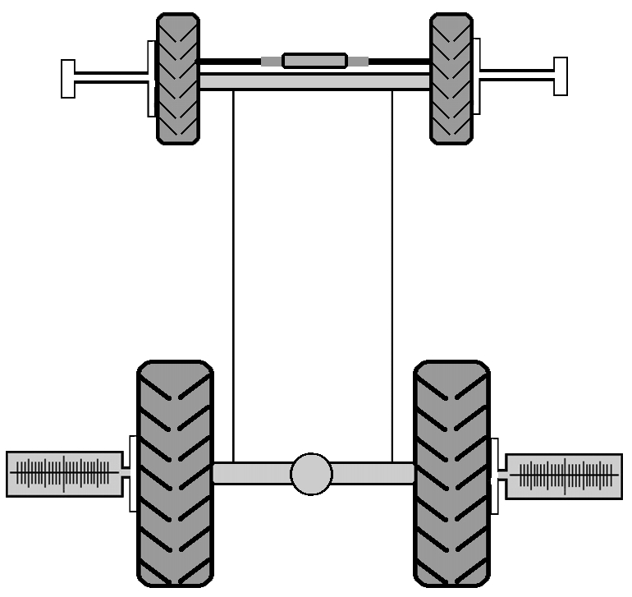
after alignment
before alignment
after alignment
before alignment

steering cylinder position

before alignment
after alignment
before alignment
after alignment
before alignment

after alignment

Mechanic: |   Date:  HAWEKA GmbH  Kokenhorststraße 4  30938 Burgwedel  Tel. +49 5139/8996-0  Fax: +49 5139/8996-222  www.haweka.com  info@haweka.com
Notes for Vehicle:
input.doc

